**Python Recursive Function**

In Python, we know that a [function](https://www.programiz.com/python-programming/function) can call other functions. It is even possible for the function to call itself. These types of construct are termed as recursive functions.

The following image shows the working of a recursive function called recurse.

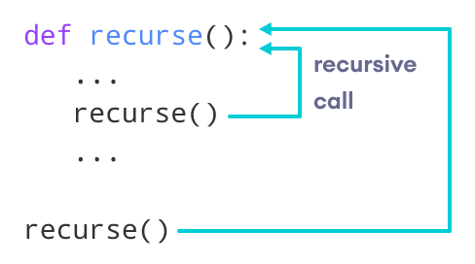Recursive Function in Python

Following is an example of a recursive function to find the factorial of an integer.

Factorial of a number is the product of all the integers from 1 to that number. For example, the factorial of 6 (denoted as 6!) is 1*2*3*4*5*6 = 720.

**Example of a recursive function**

def factorial(x):

"""This is a recursive function

to find the factorial of an integer"""

if x == 1:

return 1

else:

return (x * factorial(x-1))

num = 3

print("The factorial of", num, "is", factorial(num))

[Run Code](https://www.programiz.com/python-programming/online-compiler)

**Output**

The factorial of 3 is 6

In the above example, factorial() is a recursive function as it calls itself.

When we call this function with a positive integer, it will recursively call itself by decreasing the number.

Each function multiplies the number with the factorial of the number below it until it is equal to one. This recursive call can be explained in the following steps.

factorial(3) # 1st call with 3

3 * factorial(2) # 2nd call with 2

3 * 2 * factorial(1) # 3rd call with 1

3 * 2 * 1 # return from 3rd call as number=1

3 * 2 # return from 2nd call

6 # return from 1st call

Let's look at an image that shows a step-by-step process of what is going on:

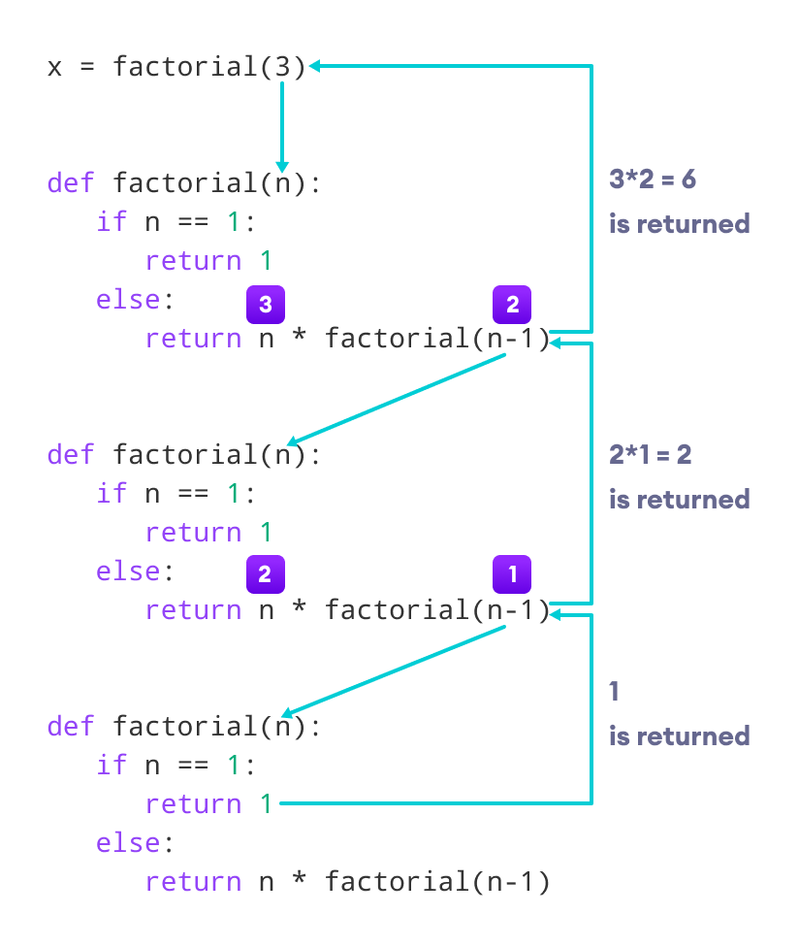Working of a recursive factorial function

Our recursion ends when the number reduces to 1. This is called the base condition.

Every recursive function must have a base condition that stops the recursion or else the function calls itself infinitely.

The Python interpreter limits the depths of recursion to help avoid infinite recursions, resulting in stack overflows.

By default, the maximum depth of recursion is 1000. If the limit is crossed, it results in RecursionError. Let's look at one such condition.

def recursor():

recursor()

recursor()

**Output**

Traceback (most recent call last):

File "<string>", line 3, in <module>

File "<string>", line 2, in a

File "<string>", line 2, in a

File "<string>", line 2, in a

[Previous line repeated 996 more times]

RecursionError: maximum recursion depth exceeded